10/5/14
Hi everyone!

Hopefully everyone has heard that preschool successfully opened our coconuts and discovered what was inside of them on Friday!

During the week, each class discussed in small and large group time what they thought was in the coconuts and how best to get them opened. Through a more discussion lead by our speech therapist, Ms. Tara, our classes narrowed down their ideas of how to open them to 2-3 options. The AM class decided on using a baseball bat, a mallet, or a hammer. The PM class attempted to open theirs by using a toy lightsaber, a mallet or a hammer. For both classes, the traditional hammer did the best job!

We also each tried a little of the coconut water/juice inside as well as most of us tried the meat of the coconut too! Some of us asked for seconds at snack time!

We also finished working with Chicka Chicka Boom Boom and read a very interesting book using our new Elmo machine onto our SMART board. We received this new ELMO machine over the summer from the FG administration and we really have enjoyed reading our books when they are projected onto the bigger screen. This was an especially fun one to read this way since all of the pictures of this book are rocks that were found. The author saw each letter of the alphabet in some way in a rock (i.e. c for couch potato or g for ghosts). If you want to see several pictures from this book, you can go to: http://www.amazon.com/If-Rocks-Could-Sing-Discovered/dp/1582463700
Quite a fun read if you are looking for something different as an alphabet book when you are at the library next!

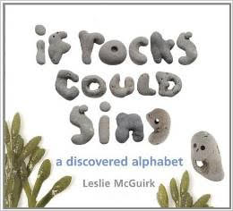

We worked with Old McDonald this week and reviewed all of our old nursery rhymes. We are really enjoying our work with Secret Stories, which is a "multi-modal, brain-based teaching ‘bag-of-tricks’ that transforms the reading and writing abilities of primary and struggling, intermediate grade learners. Through visual, auditory, and kinesthetic means, theSECRET STORIES activates every learning channel and personally connect learners to the skills." You can learn more information about the Secret Stories by going to
http://thesecretstories.com/

Mrs. Leska and I will be hosting a Secret Stories informational meeting one evening within the next month or so. We would like an opportunity to share what we have learned about the program after using it for the past year or so and what you need to know about it to help your preschooler! Date to follow soon!

Thank you all for your continued support of your preschooler!

